
EASTERN INTERNATIONAL UNIVERSITY
SCHOOL OF COMPUTING AND INFORMATION TECHNOLOGY


EDUTRACK: A SMART LEARNING CENTER MANAGEMENT SYSTEM

Huynh Khanh Duy – 2331200014
Au Duong Tai – 2331200205
Hoang Quoc Viet – 2331200183

Software Engineering

Ho Chi Minh City, August, 2026

EASTERN INTERNATIONAL UNIVERSITY
SCHOOL OF COMPUTING AND INFORMATION TECHNOLOGY


EDUTRACK: A SMART LEARNING CENTER MANAGEMENT SYSTEM

Huynh Khanh Duy – 2331200014
Au Duong Tai – 2331200205
Hoang Quoc Viet - 2331200183

Software Engineering

Ho Chi Minh City, August, 2026

ABSTRACT
In the current educational landscape, tutoring centers and private educational institutions often struggle with inefficient administrative workflows. Relying on fragmented tools or manual processes for managing student data, tracking academic progress, and handling tuition payments leads to administrative bottlenecks and a lack of transparency between the center, students, and parents.
To address these challenges, this project introduces EduTrack, a Smart Learning Center Management System designed to centralize and automate daily educational operations.
As part of the Software Engineering Capstone Project I, the current phase focuses on comprehensive system analysis, architectural design, and UI/UX prototyping. EduTrack is structured to serve three primary user groups encompassing five distinct roles: Administration (Center Manager, Staff), Academic (Teacher, Teaching Assistant), and End-Users (Student). Rather than exhaustively detailing all system features, the core modules designed in this phase highlight critical operations, including centralized user and student management, class and subject management, tuition and approval workflows, teaching and student progress monitoring, notification management, and reporting. Furthermore, the system architecture incorporates AI-powered integrations designed to provide smart educational support, thereby enhancing both teaching efficiency and student learning experience.
By establishing a solid architectural foundation and clear logic workflows, the proposed system aims to deliver comprehensive benefits across all user levels. For administrators, it significantly reduces manual workloads and streamlines center operations. For teaching staff, the integration of AI and automated tools simplifies class management and evaluation processes. For end-users, it guarantees transparent, real-time insights into learning outcomes and financial records. Ultimately, the deliverables of this phase serve as a robust blueprint for the full technical implementation in Capstone Project II, III.

ACKNOWLEDGEMENT
We would like to express our sincere gratitude to our lecturer, Mr. Ung Van Giau, for providing valuable knowledge, guidance, and support throughout the Software Engineering Capstone Project I.
We are deeply grateful to the lecturers who share insights regarding academic administration and student progress tracking workflows, which greatly contributed to the design and development of the EduTrack system, with us.

TABLE OF CONTENTS
ABSTRACT i
ACKNOWLEDGEMENT ii
TABLE OF CONTENTS iii
LIST OF FIGURES v
LIST OF TABLES vi
LIST OF ABBREVIATIONS vii
CHAPTER 1. INTRODUCTION 1
1.1. Motivation 1
1.2. Project Objectives 1
1.3. Project Scope 2
1.4. Organization of the project 2
CHAPTER 2. RELATED WORKS 3
2.1. TutorBird 3
2.2. Easy Edu 3
2.3. EduSpace 3
2.4. Moodle 4
2.5. Summary and The Need for EduTrack 4
CHAPTER 3. SYSTEM ANALYSIS & DESIGN 6
3.1. System Requirements 6
3.1.1. Functional Requirements 6
3.1.2. Non-functional Requirements 9
3.2. Use Case Diagram 9
3.2.1. Actors 9
3.2.2. Use Cases 9
3.2.3. General Use Case Diagram 10
3.3. Overall System Architecture 12
3.3.1. Architectural Overview 12
3.3.2. Presentation Layer 12
3.3.3. Application and Backend Layer 13
3.3.4. Data Layer 13
3.3.5. Authentication and Authorization 14
3.3.6. LLM Integration 14
3.4. Technologies 15
3.4.1. React TypeScript 15
3.4.2. ASP.NET Core Web API 15
3.4.3. Database Design 16
3.4.4. Authentication 16
3.5. Database Design 17
3.6. Feature and Page Analysis 33
CHAPTER 4. RESULTS & DISCUSSION 37
4.1. Center Manager and Admin Staff UIs 37
4.2. Teacher and TA UIs 39
4.3. Student UIs 40
CHAPTER 5. CONCLUSION & FUTURE WORKS 42
5.1. Conclusion 42
5.2. Future Works 42
REFERENCES 43

LIST OF FIGURES
Figure 1. General Use Case Diagram 10
Figure 2. Overall System Architecture 12
Figure 3. General ERD 17
Figure 4. User Authentication and Role Management ERD 17
Figure 5. Academic Structure and Class Enrollment ERD 18
Figure 6. Class Scheduling, Session, and Attendance ERD 18
Figure 7. Learning Content and Assignment Management ERD 19
Figure 8. Tuition Payment and Approval Management ERD 20
Figure 9. UI Prototype of Admin Staff Dashboard 37
Figure 10. UI Prototype of Center Manager Notification Management 38
Figure 11. UI Prototype of Tuition Report 39
Figure 12. Teacher Dashboard Prototype 39
Figure 13. Class Schedule Interface Prototype 40
Figure 15. Class Detail interface for Students 40
Figure 16. Interactive weekly schedule interface. 41

LIST OF TABLES
Table 1. Center Manager Requirements 6
Table 2. Admin Staff Requirements 7
Table 3. Teacher Requirements 7
Table 4. Teaching Assistant Requirements 8
Table 5. Student and Parent Requirements 8
Table 6. Non-functional Requirements 9
Table 7. Technology Stack 15
Table 8. Users table 20
Table 9. Roles table 21
Table 10. User_roles table 22
Table 11. Subjects table 22
Table 12. Classes table 22
Table 13. Teacher_classes table 23
Table 14. Ta_classes table 23
Table 15. Student_classes table 24
Table 16. Class_schedules table 24
Table 17. Class_sessions table 24
Table 18. Content_units table 25
Table 19. Attendance table 26
Table 20. Assignments table 26
Table 21. Submissions table 27
Table 22. AI_evaluations table 27
Table 23. Progress_notes table 28
Table 24. Tuition_invoices table 29
Table 25. Payment table 29
Table 26. Approval_requests table 30
Table 27. Notifications table 32
Table 28. Center_settings table 32
Table 29. Center Manager & Admin Staff Pages 33
Table 30. Teacher & Teaching Assistant Pages 34
Table 31. Student Pages 35
Table 32. Landing Page 36

LIST OF ABBREVIATIONS
No. | Term | Meaning
1 | API | Application Programming Interface
2 | ERD | Entity-Relationship Diagram
3 | JWT | JSON Web Token
4 | TA | Teaching Assistant
5 | UI | User Interface
6 | UX | User Experience
7 | LLM | Large Language Model
8 | CRM | Customer Relationship Management

INTRODUCTION
This chapter presents the primary motivation driving the need for a centralized learning center management system, outlines the core objectives, and defines the scope of the project. Finally, it concludes with a brief outline of the organization of the remaining chapters in this report.

Motivation
Currently, many individual teachers or groups of teachers have opened classes based on a tutoring center model to organize teaching activities in a more systematic and professional manner [1]. However, this transition introduces new challenges, such as managing students, tracking learning progress, scheduling classes, and controlling tuition payments. As a result, managing records via Excel, messaging apps, or personal notes can be time-consuming and lead to tracking errors, including confusion over student information, class schedules, classes, teachers, and teaching assistants. Therefore, these centers require a centralized system to manage students, classes, subjects, teachers, and tuition fees clearly and transparently [2]. This is a practical need for growing centers that still depend on manual methods. The EduTrack project is developed to support remote, centralized information management, aiming to reduce manual workloads and minimize errors.

Project Objectives
The primary objective of this project is to design and develop EduTrack—a comprehensive, centralized Web Application for learning center management tailored specifically to the operational needs and financial constraints of growing, small-to-medium tutoring centers. The project is structured around four primary objective pillars, aligning the system's technical design with practical operational requirements:
- Cross-browser and Platform Compatibility: Ensure that the web-based system operates seamlessly across all major modern web browsers, including Google Chrome, Safari, Microsoft Edge, and Firefox. This compatibility guarantees zero service interruption and consistent functionality regardless of the client’s local operating system or browser software.
- Responsive Design: Deliver a highly responsive, modern, and accessible user interface using React and TypeScript. The frontend layouts must dynamically adapt to various screen sizes and device viewports—including desktop computers, tablets, and mobile phones—to optimize the usability and user experience (UX) for all five system roles.
- Core Functional Delivery: Provide a robust digital platform for core academic and administrative operations. This includes user management, class management, class operations, reporting, approval request, and role-based access control. AI Assistance Integration is also prioritized as a core educational helper. The system is designed to assist teachers by automatically generating suggested scores and qualitative feedback. While the specific LLM API provider and connection SDKs will be finalized in Capstone II and III, the database design and backend routing are fully established in this phase. Moreover, to prevent scope creep and ensure technical design depth, the Tuition module in this phase is strictly focused on Billing and Invoice Generation (Billing only), while the Notification module is strictly limited to static, in-app database-driven alerts. Complex third-party integrations—specifically automated notification gateways (such as SMS, Zalo ZNS, or SMTP email APIs) and online payment gateways (such as VNPAY or MoMo)—are explicitly designated as Supporting Features to be explored and developed in future phases as time permits.
- Deliver complete system architecture, database schemas, and UI prototypes as the foundation for Capstone Project II and III.

Project Scope
The scope of this project is strictly defined according to the academic requirements of Capstone Project I. Rather than delivering a fully coded and deployed application, the boundary of this current phase focuses exclusively on foundational software engineering processes, including system analysis, architectural design, and prototyping. Specifically, the scope of work encompasses system requirement analysis to elicit and define functional and non-functional requirements across all designated user roles. It also involves designing the relational database architecture, utilizing Entity-Relationship (ER) diagrams to securely manage entities such as users, classes, assignments, and tuitions. Furthermore, this phase includes mapping out detailed system workflows for core business processes, alongside analyzing the essential pages and core features required for the system. To visualize the system layout, the scope also covers UI/UX prototyping through the design of key interface mockups. Consequently, full-scale technical coding, system deployment, and complex third-party API integrations—such as AI models or live payment gateways—fall outside the scope of Capstone Project I and are reserved for future implementation in Capstone Project II, III.

Organization of the project
- Chapter 1 — Introduces motivation, objectives, scope, and organization of the project.
- Chapter 2 — Provides information about related works.
- Chapter 3 — Describes the requirements and analyzes the system design.
- Chapter 4 — Provides static UI mockups.
- Chapter 5 — Shows conclusion, and future works

RELATED WORKS
This chapter shows a review of existing educational management systems to identify their limitations and highlight the practical need for EduTrack.

TutorBird
TutorBird [3] is a widely recognized management platform tailored for private tutors and tutoring centers. It focuses on simplifying scheduling, billing, and student management.
- Strengths: The platform offers a highly user-friendly interface accompanied by dynamic page transitions and comprehensive documentation, including video tutorials. It streamlines administrative tasks by supporting data importing (via Excel/CSV), calendar-based scheduling, and online payments. Furthermore, it provides automated reminder notifications for fixed payment due dates and offers sample assignment templates for teachers.
- Limitations: Despite its usability, TutorBird presents several rigid constraints. Creating a student profile strictly requires parent information, which may not always be applicable. Financial operations are also inflexible; tuition fees are fixed upon setup and difficult to adjust mid-course, and the payment gateway is restricted to a single currency (USD). Additionally, users frequently experience slow data loading times during page transitions.

Easy Edu
Easy Edu [4] is a comprehensive educational management software popular in the Vietnamese market, designed to support various educational models including online, offline, and hybrid tutoring.
- Strengths: The system significantly optimizes management workflows and human resource operations, claiming to reduce management time by 80% and administrative costs by 50%. It features a built-in ecosystem for online teaching and testing, and an advanced CRM (Customer Relationship Management) for customer care, and automates up to 90% of financial and accounting tasks. Furthermore, it ensures robust data security through three-layer authorization and firewall protection.
- Limitations: The primary drawback of Easy Edu is its pricing model. The service requires a daily maintenance fee calculated per user (e.g., 2,000 VND/day/user). Consequently, operational costs increase linearly and significantly as the center expands its staff and student base, creating a financial burden for newly emerging centers.

EduSpace
EduSpace [5] is another robust centralized management platform that emphasizes communication, flexible billing, and E-learning integration.
- Strengths: EduSpace boasts an intuitive and simple interface that strictly manages student statuses, including attendance, course reservations, and makeup classes. It offers highly flexible tuition processing with automated payment reminders integrated via Zalo and Email. The platform also supports diverse salary calculation mechanisms, E-learning capabilities (course creation, online exams), and allows for unlimited staff members and facility branches.
- Limitations: Similar to Easy Edu, the limitations of the EduSpace lie in its commercial subscription model. The platform is divided into various tiered service packages. Costs escalate rapidly when the number of students or CRM contacts exceeds the package limits. Furthermore, it mandates annual billing, which imposes a high initial financial burden on smaller tutoring centers.

Moodle
Moodle [6] is a prominent open-source Learning Management System designed for delivering educational content, facilitating interactive online courses, and rigorously evaluating student academic progress in a centralized digital environment.
- Strengths: As a free, open-source platform, Moodle offers extensive customization without costly software licenses. A large global community provides thousands of free add-ons, easily enabling advanced functions like detailed quizzes and video meeting integration. Additionally, it provides excellent support for teaching through reliable grading systems and clear student progress tracking.
- Limitations: The main drawback of Moodle is its high demand for technical skills, requiring a dedicated IT team for server hosting, initial setup, and regular maintenance. Moreover, the platform is not designed to function as a complete business management system for educational centers. Because it lacks essential administrative tools for scheduling classes, calculating staff pay, and processing tuition fees, it is highly impractical for daily operations.

Summary and The Need for EduTrack
Existing systems like TutorBird, Easy Edu, and EduSpace provide solutions for managing educational and tutoring centers with a variety of features such as student management, scheduling, attendance, billing, and online payment for TutorBird, as well as broader functions for student management, tuition, classes, financial operations, and other administrative activities for Easy Edu and EduSpace. Meanwhile, open-source LMS platforms like Moodle excel in content delivery and academic tracking but lack built-in center management and business operational tools. Furthermore, commercial systems differ significantly in pricing models, operational scope, and target users; Easy Edu adopts a user-based pricing model, while EduSpace provides tiered plans based on the number of students. These differences show that existing solutions may not be able to meet the specific operational demands and management model targeted by this project.
Therefore, EduTrack is proposed as a tailored, cost-effective, and centralized solution. It focuses strictly on the core administrative necessities-student tracking, assignment management, attendance, and basic tuition control without the financial overhead or feature bloat of commercial alternatives.

SYSTEM ANALYSIS & DESIGN
This chapter details the system requirements of the EduTrack system. It also presents use case, system architecture, and activity diagrams to visualize user interactions and system workflows. Furthermore, it provides a complete database design, including Entity-Relationship Diagrams (ERD) and detailed table descriptions. Finally, it outlines the essential pages and core features required for the system to function effectively.

System Requirements
This section defines the core capabilities that the EduTrack system must possess to meet the needs of all users. It is divided into Functional Requirements, which describe specific system behaviors for each user role, and Non-functional Requirements, which define the performance and quality standards of the system.

Functional Requirements
To ensure clear organization, the functional requirements are grouped based on the five primary user roles: Center Manager, Admin Staff, Teacher, Teaching Assistant (TA), and Student/Parent.
Group 1: Center Manager, this role has the highest level of access. Table 1 outlines the requirements for managing the entire center, including accounts, academic structures, and financial policies.
Table 1. Center Manager Requirements
ID | Feature | Description
CM-01 | Account Management | Allows the Center Manager to create, update, lock, or unlock user accounts, and assign or revoke their roles.
CM-02 | Academic Management | Enable the Center Manager to create and manage subjects and classes, and assign teachers, TAs, and students to them.
CM-03 | Center Dashboard | Provides a dashboard to monitor overall statistics regarding students, classes, staff, and tuition.
CM-04 | Student Monitoring | Allow the Center Manager to monitor student attendance, assignments, and learning progress.
CM-05 | Reporting | Enables the Center Manager to view and export detailed reports on students, classes, tuitions, and revenue.
CM-06 | Tuition Configuration | Allows the Center Manager to set tuition fees, collection dates, deadlines, and discount policies for each subject or class.
CM-07 | Global Announcements | Allows the Center Manager to send notifications to the entire center, specific classes, or target user groups.
CM-08 | Center Settings | Enable the Center Manager to update the center's general information and system settings.
CM-09 | Request Approval | Allows the Center Manager to approve or reject special adjustment requests (e.g., fee waivers, refunds, special class transfers) submitted by Admin Staff.

Group 2: Admin Staff handle daily operations, customer support, and basic financial tracking.
Table 2. Admin Staff Requirements
ID | Feature | Description
AD-01 | Profile Management | Allows Admin Staff to create and update student and parent profiles, and link parents to their children.
AD-02 | Search Profiles | Enables Admin Staff to search and view student profiles by name, ID, class, or learning status.
AD-03 | Enrollment Operations | Allows Admin Staff to enroll students into classes, transfer them, or update their status (e.g., paused, finished).
AD-04 | Class Information | Allows Admin Staff to view class schedules, assigned teachers, and update class details within their permission scope.
AD-05 | Tuition Recording | Allows Admin Staff to record tuition payments, including the amount, payment date, method, and notes.
AD-06 | Tuition Status | Enables Admin Staff to update and track tuition statuses (unpaid, paid, or overdue).
AD-07 | Notifications | Allows Admin Staff to send notifications regarding schedules, class changes, and tuition reminders to students and parents.
AD-08 | Basic Reporting | Allows Admin Staff to view and export basic reports regarding students and tuition collection.
AD-09 | Feedback Handling | Allows Admin Staff to receive, record, and respond to feedback or requests from students and parents.
AD-10 | Escalate Requests | Enables Admin Staff to submit special requests (fee waivers, refunds) to the Center Manager for approval.
AD-11 | Teaching-Monitoring | Allows Admin Staff to monitor teaching activities by teachers, class subject, attendance, assignment completion, and student learning progress.

Group 3: Teachers focus on class management, grading, and student progress tracking.
Table 3. Teacher Requirements
ID | Feature | Description
TC-01 | Account Login | Allows Teachers to securely log into the system and recover forgotten passwords via email.
TC-02 | View Classes | Allows Teachers to view the details and schedules of their assigned classes.
TC-03 | Attendance | Enables Teachers to take and manage student attendance for their classes.
TC-04 | Assignment Management | Allows Teachers to create, assign, and grade homework for students.
TC-05 | Progress Tracking | Allows Teachers to track student learning progress and send academic feedback to parents.
TC-06 | Issue Reporting | Enables Teachers to report schedule issues or class problems to the Admin Staff.
TC-07 | AI Assistance | Integrates LLM tools to support Teachers in automatically grading standard assignments.

Group 4: Teaching Assistants (TA) support the teachers in managing the classroom and checking assignments.
Table 4. Teaching Assistant Requirements
ID | Feature | Description
TA-01 | Account Login | Allows TAs to securely log into the system and recover forgotten passwords via email.
TA-02 | View Classes | Allows TAs to view the details and schedules of their assigned classes.
TA-03 | Assist Attendance | Allows TAs to assist in taking student attendance.
TA-04 | Class Notes | Enables TAs to write and save notes regarding the daily class situation.
TA-05 | Assist Grading | Allows TAs to check and grade specific assignments if granted permission by the Teacher.
TA-06 | Issue Reporting | Allows TAs to report class issues directly to the Teacher or Admin Staff.

Group 5: This group represents the end-users who consume the center's services.
Table 5. Student and Parent Requirements
ID | Feature | Description
ST-01 | Account Access | Allows Students/Parents to log in with admin-provided accounts and recover passwords via phone or the parent app.
ST-02 | View Information | Allows Students/Parents to view their class schedules, and view or update basic personal information.
ST-03 | Submit Assignments | Enables Students to view assigned homework and submit their answers online.
ST-04 | View Progress | Allows Students/Parents to view academic progress and read feedback from Teachers.
ST-05 | Receive Notifications | Enables Students/Parents to receive system notifications from classes or the center.
ST-06 | Tuition Payment | Enables Students and Parents to view their current tuition status and make online tuition payments.

Non-functional Requirements
Beyond the specific features, the system must maintain a high standard of quality, security, and usability. Table 6 outlines the non-functional requirements that guide the system's technical architecture.
Table 6. Non-functional Requirements
ID | Category | Description
NFR-01 | Security | The system shall securely hash user passwords and use JWT for authenticated sessions.
NFR-02 | Usability | The user interface of the system shall be responsive and function seamlessly across desktop computers, tablets, and mobile phones.
NFR-03 | Compatibility | The system shall be compatible with all major modern web browsers (Google Chrome, Safari, Microsoft Edge, Firefox).

Use Case Diagram

Actors
Main actors include:
- Center Manager
- Admin Staff
- Teacher
- Teaching Assistant
- Student

Use Cases
General use cases include:
- Manage Center Operations
- Manage Accounts
- Process Finances
- Execute Learning Activities
- Handle Communications
- Handle Administrative Tasks
- Manage User Profile
- Configure System

General Use Case Diagram
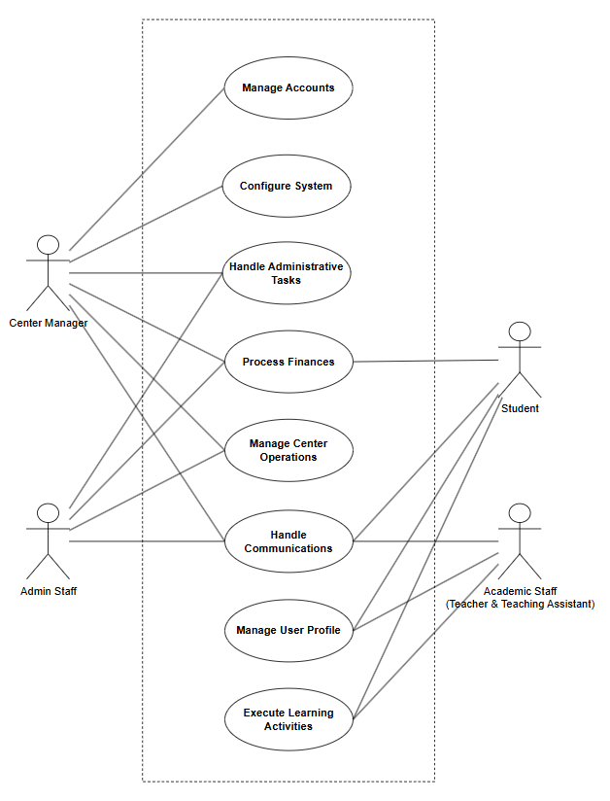

Figure 1. General Use Case Diagram

Center Manager: As the top administrator, the Center Manager has full control over the system and can also perform all tasks assigned to the Admin Staff.
- Configure System: Sets up general system rules and manages settings for the entire center.
- Manage System Accounts: Creates, updates, and manages accounts and access rights for everyone in the system.
- Process Workflows: Reviews and approves internal staff requests. This actor also views general performance reports.
- Handle Communications: Sends, receives, and manages messages for the whole center or specific groups.
Admin Staff: The Admin Staff handles the daily office work and financial tasks of the center.
- Manage Center Operations: Manages student records, subjects, class schedules, and checks on daily teaching activities.
- Process Finances: Handles money matters by creating bills, sending reminders, and keeping track of tuition records.
- Process Workflows: Sends internal requests for the Center Manager to approve and views system reports.
- Handle Communications: Manages daily messages and announcements for staff and clients.
Academic Staff (Teacher & Teaching Assistant): Teacher and Teaching Assistant focus on teaching, grading, and keeping track of student progress.
- Execute Learning Activities: Use the system to view assigned classes, teaching schedule, create and assign homework, grade student work, and check overall students performance.
- Manage Personal Profile: View and update their own personal information and account settings.
- Handle Communications: Send class-related messages to students and receive updates from the administration.
Student: The Student uses the system to follow classwork and pay tuition fees.
- Execute Learning Activities: Checks learning resources, submits homework, and views learning progress.
- Process Finances: Views bills and pays tuition fees through the system.
- Manage Personal Profile: Views and updates their own personal details and account settings.
- Handle Communications: Receives messages about schoolwork, payment due dates, and general center news.

Overall System Architecture
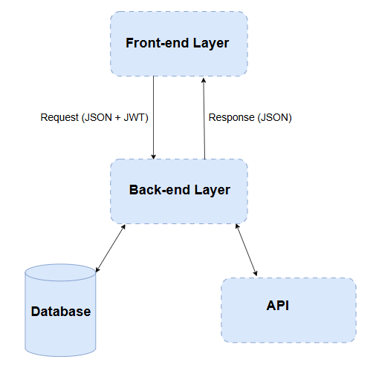
Figure 2. Overall System Architecture

Architectural Overview
The proposed system is a web-based Learning Center Management System designed to support the management and operation of a learning center. The system provides functions for managing staff, students, courses, assignments, submissions, grades, and learning-related information. In addition, a Large Language Model (LLM) API is integrated to provide AI-assisted grading and feedback.
The system adopts a layered three-tier architecture consisting of the presentation layer, application/backend layer, and data layer. An additional LLM integration component is implemented within the backend to communicate with external Large Language Model services.
The architecture was selected to improve maintainability, scalability, security, and separation of concerns. Each layer is responsible for a specific set of functions and communicates with other layers through well-defined interfaces.

Presentation Layer
The presentation layer is implemented using React and TypeScript. It provides the user interface through which administrators, teachers, and students interact with the system.
The main functions of the presentation layer include:
- User authentication and session management
- Student, staff, and teacher profile management
- Class scheduling, session, and attendance tracking
- Assignment, submission, and grading workflows
- AI-assisted grading and feedback review
- Dashboard statistics and analytical reporting
React components are organized into reusable components, pages, layouts, and feature-specific modules. TypeScript is used to provide static type checking and improve code reliability and maintainability.
The Front-end communicates with the backend through RESTful APIs over HTTPS. JWT Bearer Tokens are attached to authenticated API requests to ensure that users can only access functions permitted by their roles.

Application and Backend Layer
The backend is developed using ASP.NET Core Web API. It provides RESTful APIs for business operations and acts as the main communication layer between the React application, MySQL database, and external LLM services.
The backend is organized into several logical components:
- Controllers: Controllers receive HTTP requests from the frontend, validate request parameters, and invoke appropriate business services.
- Service Layer: The service layer contains the main business logic of the system. Examples include StudentService, StaffService, CourseService, AssignmentService, AttendanceService, GradingService, and UserService.
- Data Access Layer: The data access layer manages communication with the MySQL database using Entity Framework Core. It is responsible for retrieving, creating, updating, and deleting persistent data.
- API Security & Authorization: Coordinates with the security middleware to intercept incoming requests, validate JWT signatures, and enforce role-based access before business logic execution.
This separation of responsibilities allows the backend to be easier to test, maintain, and extend.

Data Layer
MySQL is used as the primary relational database management system. The database stores the persistent data required by the learning center management system. The main entities may include:
- User, Role, and UserRole (Account & Authorization)
- Subject, Class, TeacherClass, TaClass, and StudentClass (Academic & Enrollments)
- ClassSchedule and ClassSession (Scheduling & Timetables)
- ContentUnit, Attendance, and ProgressNote (Learning & Tracking)
- Assignment and Submission (Coursework & Evaluations)
- TuitionInvoice and Payment (Financial Operations)
- ApprovalRequest (Administrative Approvals)
- Notification and CenterSetting (Communication & Configurations)
Entity Framework Core is used as the Object-Relational Mapping (ORM) framework between ASP.NET Core and MySQL. This approach allows application entities to be represented as strongly typed C# classes while reducing the amount of manually written SQL code.

Authentication and Authorization
Security is an important aspect of the proposed system because the application manages personal information, academic records, assignments, and grades.
The system uses JSON Web Token (JWT) based authentication. After successful login, the Back-end generates a JWT containing relevant user information and authorization claims. The Front-end uses the token when accessing protected API endpoints.
The authentication process can be summarized as follows:
- The user submits login credentials through the React application.
- The ASP.NET Core API validates the credentials against the hashed records.
- If the credentials are valid, the server generates a JWT.
- The frontend stores and uses the token for authenticated API requests.
- The backend validates the JWT signature and claims for each protected request.
Role-based authorization determines whether the user is allowed to perform the requested operation. For example, an administrator may manage staff and students, while a teacher may create assignments and grade submissions. Students and parents may access their courses, assignments, submissions, and grades but cannot modify grades.
Passwords are never stored as plain text; a secure password hashing mechanism is used for credential storage.

LLM Integration
The system integrates a Large Language Model API to provide AI-assisted grading and feedback.
The LLM integration is implemented as a separate backend service rather than allowing the React application to communicate directly with the LLM provider. This design prevents API credentials from being exposed to client-side code and allows the backend to control prompts, validation, logging, and access policies.
For an AI-assisted grading request, the backend provides the LLM with:
- Assignment description
- Grading rubric
- Maximum score
- The answer or submission of student
- Assessment criteria and additional grading instructions
The LLM returns a structured grading result containing a suggested score and feedback. The backend validates and stores the result before presenting it to the teacher.
The proposed workflow follows a human-in-the-loop approach. The AI provides a suggested grade and feedback, while the teacher reviews and confirms the final result. This approach reduces the risk of relying entirely on automatically generated grades.

Technologies
Table 7. Technology Stack
Category | Technology | Description
Front-end | HTML5, CSS3, React, TypeScript | Component-based library and strongly typed language used to build scalable, interactive user interfaces.
Back-end | ASP.NET Core 8.0 (C#) | Cross-platform framework used to implement backend services, routing, and business logic.
Database | MySQL | Relational database management system used for persistent data storage.
Authentication | JWT (JSON Web Token) | Stateless authentication mechanism used to secure API endpoints and user sessions.

React TypeScript
For the Front-end, we specifically chose React [7] with TypeScript [8] (React TS) to create a modern and user-friendly interface. While React allows us to build reusable UI components efficiently, using plain JavaScript can sometimes lead to unexpected errors. TypeScript solves this by providing static typing. This helps us catch code errors early during development, making the source code much cleaner, safer, and easier to maintain in the long run.

ASP.NET Core Web API
The Back-end of the EduTrack system is built using ASP.NET Core Web API [9]. We chose this framework because it provides a strong and secure way to handle all the business logic, such as managing students, teachers, classes, and tuition fees. It is fast and works perfectly with Entity Framework, which makes saving and updating database records much easier. By separating the backend from the Front-end, we can develop, test, and maintain the system's logic without affecting the user interface.

Database Design
To store all the system data, we use MySQL [10]. While SQL Server is a common choice for .NET projects, it can cause difficulties during real-world deployment due to high licensing costs. Therefore, we chose MySQL because it is a reliable, open-source, and free relational database that is perfect for managing connected data in a learning center. To connect our ASP.NET Core backend with the MySQL database, we use Pomelo, which is a highly optimized and widely used provider for this setup. During the development phase, we run MySQL Community Server locally and use MySQL Workbench to easily design database tables.

Authentication
For user authentication, we use JSON Web Tokens (JWT) [11]. We chose JWT because it is lightweight, stateless, and integrates easily between React and ASP.NET Core. Instead of storing user sessions on the server, the client sends a secure token with each request to verify the user's identity and role (such as student, teacher, or admin). This keeps backend server memory low, improves response speed, and ensures safe access to sensitive endpoints across the EduTrack system.

Database Design
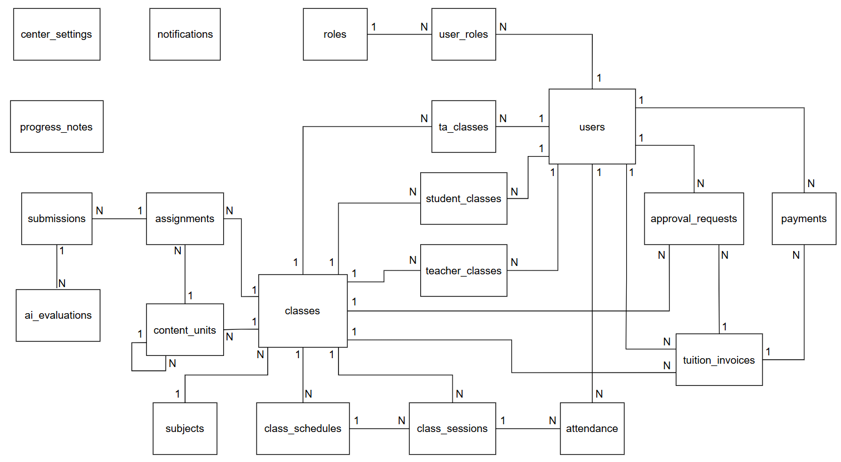
Figure 3. General ERD
This system-wide ERD connects users and their assigned roles to classes and subjects, integrates curriculum and evaluation via content_units, assignments, and submissions, manages operational workflows like class_schedules, class_sessions, and attendance, and supports administrative processes through tuition_invoices, payments, and approval_requests.

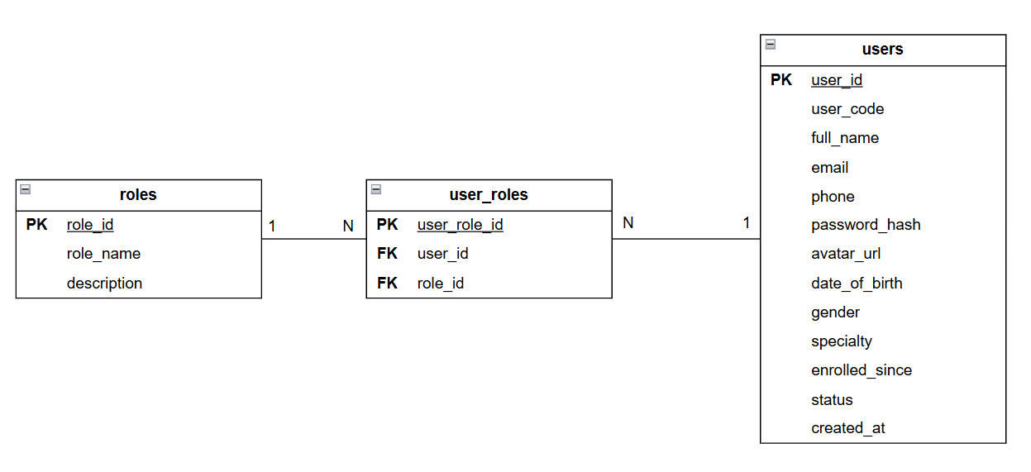
Figure 4. User Authentication and Role Management ERD
The EduTrack user management structure uses Role-Based Access Control (RBAC). The users table stores common account information, while roles define system roles and user_roles manage the many-to-many relationship between users and roles.

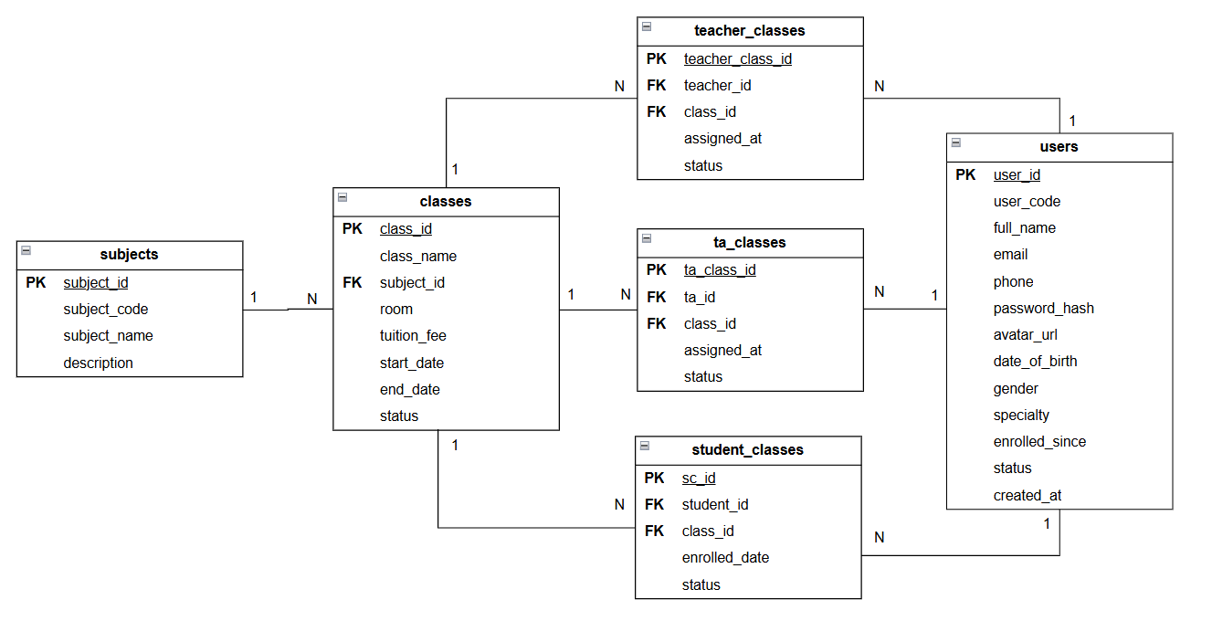
Figure 5. Academic Structure and Class Enrollment ERD
The academic structure connects subjects with classes and manages class participation through dedicated assignment tables. Teachers, teaching assistants, and students can be associated with multiple classes through teacher_classes, ta_classes, and student_classes.

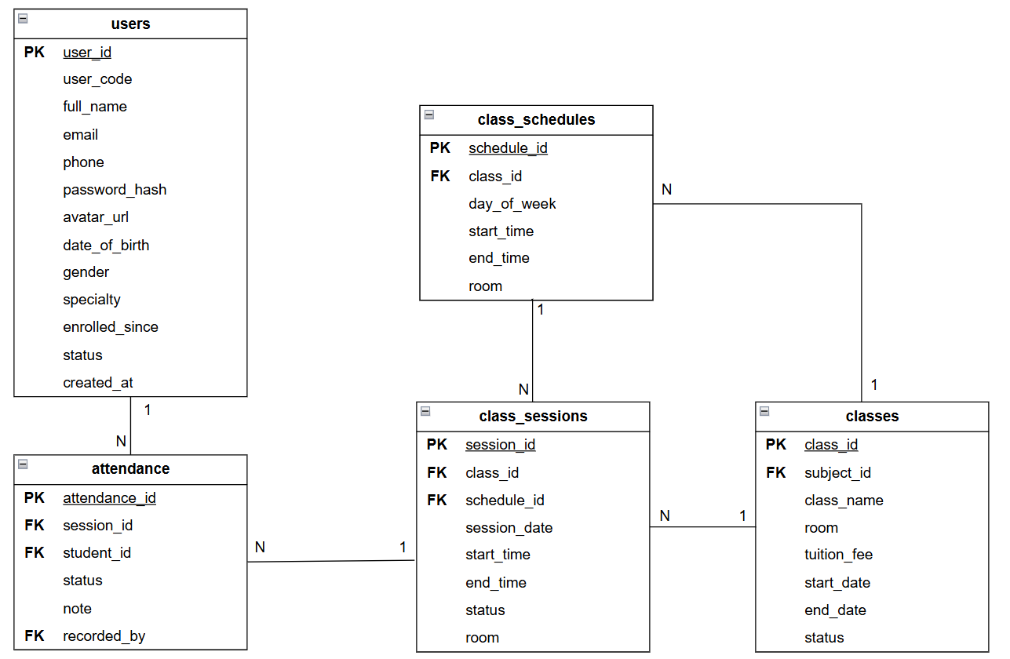
Figure 6. Class Scheduling, Session, and Attendance ERD
The scheduling structure separates recurring class schedules from actual teaching sessions. Each class may have multiple scheduled time slots and individual sessions, while attendance is recorded for each student based on a specific session.

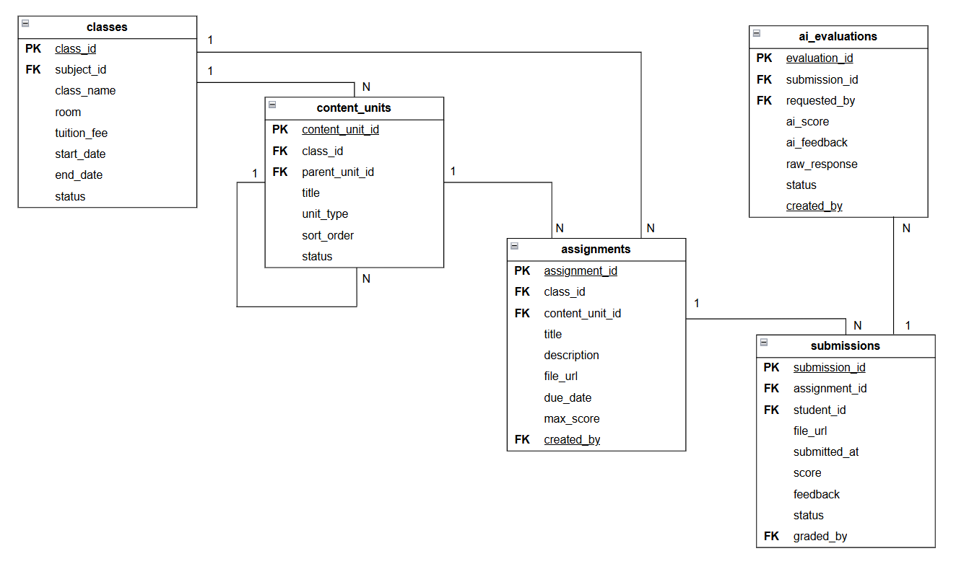
Figure 7. Learning Content and Assignment Management ERD
Learning content is organized through the self-referencing content_units table, allowing hierarchical structures such as chapters and lessons. Assignments are associated with classes and may optionally be linked to a specific content unit, while student submissions are recorded separately.

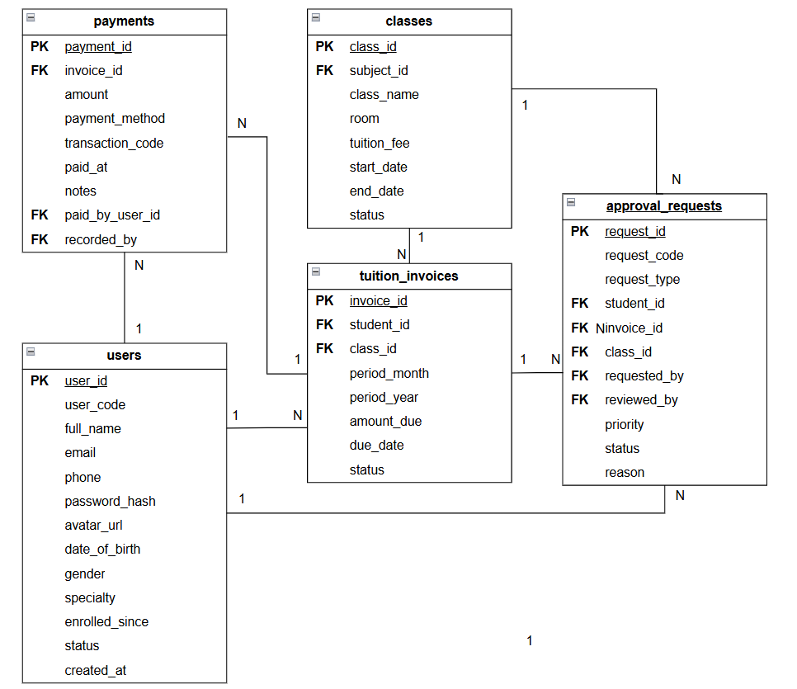
Figure 8. Tuition Payment and Approval Management ERD
The tuition structure manages student invoices, payment records, and exceptional approval requests. Each invoice may contain multiple payment records, while approval requests support tuition-related and class-related exceptions that require managerial review.

Table 8. Users table
Attribute | Data Type | Key | Constraints | Description
user_id | INT | PK | AUTO_INCREMENT, NOT NULL | Unique internal identifier for the user record
user_code | VARCHAR(20) |  | UNIQUE, NOT NULL | Unique account login code / username assigned by Admin (e.g., MGR001, TC001, STU001)
full_name | VARCHAR(150) |  | NOT NULL | Full legal name of the user
email | VARCHAR(150) |  | UNIQUE, NULL | User's email address (can also be used as a login identifier)
phone | VARCHAR(20) |  | NULL | Contact telephone number (can also be used for identification)
password_hash | VARCHAR(255) |  | NOT NULL | Cryptographically hashed password provisioned by Admin
avatar_url | VARCHAR(500) |  | NULL | URL pointing to the user's profile image
date_of_birth | DATE |  | NULL | Date of birth
gender | ENUM |  | 'male', 'female', 'other' | Gender of the user
specialty | VARCHAR(100) |  | NULL | Academic subject specialty for teachers (e.g., Mathematics, Physics)
enrolled_since | DATE |  | NULL | Enrollment date for students or hiring date for staff/teachers
status | ENUM |  | 'active', 'inactive', 'on_hold', 'locked', Default: 'active' | Current operational status of the account
created_at | DATETIME |  | NOT NULL, Default: CURRENT_TIMESTAMP | Timestamp when the account was provisioned by Admin
Description: Centralized entity storing user account credentials, authentication details, and personal profiles for all system roles (Center Managers, Admin Staff, Teachers, Teaching Assistants, and Students). All accounts and initial passwords are created and provisioned directly by the Center Manager.

Table 9. Roles table
Attribute | Data Type | Key | Constraints | Description
role_id | INT | PK | AUTO_INCREMENT, NOT NULL | Unique internal identifier for the role
role_name | VARCHAR(50) |  | UNIQUE, NOT NULL | Name of the role
description | TEXT |  | NULL | Detailed description of the role’s responsibilities and permission scope
Description: Master lookup table storing system authority roles. It defines the operational scopes for access control and can be dynamically extended by administrators.

Table 10. User_roles table
Attribute | Data Type | Key | Constraints | Description
user_role_id | INT | PK | AUTO_INCREMENT, NOT NULL | Unique internal identifier for the role assignment record
user_id | INT | FK | NOT NULL, References users(user_id) | Foreign key referencing the assigned user account
role_id | INT | FK | NOT NULL, References roles(role_id) | Foreign key referencing the granted role
Description: Junction table managing the Many-to-Many (N:M) relationship between users and roles. It enables role-based access control (RBAC), allowing a single user account to hold multiple system roles simultaneously (e.g., a teacher who is also an administrator).

Table 11. Subjects table
Attribute | Data Type | Key | Constraints | Description
subject_id | INT | PK | AUTO_INCREMENT, NOT NULL | Unique internal identifier for the subject
subject_code | VARCHAR(20) |  | UNIQUE, NOT NULL | Short academic code identifying the subject (e.g., MATH, PHYS, CHEM, ENG)
subject_name | VARCHAR(150) |  | NOT NULL | Full official name of the subject (e.g., Mathematics, Physics)
description | TEXT |  | NULL | Detailed description of the subject curriculum and learning objectives
Description: Academic catalog storing all subjects offered by the learning center. It serves as the foundation for creating course sections and assigning specialized teaching staff.

Table 12. Classes table
Attribute | Data Type | Key | Constraints | Description
class_id | INT | PK | AUTO_INCREMENT, NOT NULL | Unique identifier for the class section
class_name | VARCHAR(100) |  | NOT NULL | Name of the class (e.g., Class 7 - Mathematics)
subject_id | INT | FK | NOT NULL, References subjects(subject_id) | Identifier of the associated subject
room | VARCHAR(50) |  | NULL | Assigned physical or virtual classroom
tuition_fee | DECIMAL(12,2) |  | NOT NULL, Default: 0.00 | Monthly tuition rate in VND
start_date | DATE |  | NULL | Class start date
end_date | DATE |  | NULL | Class end date
status | ENUM |  | 'active', 'inactive', Default: 'active' | Operational status of the class
Description: Stores concrete class offerings associated with academic subjects, classroom information, tuition fees, operating periods, and class status.

Table 13. Teacher_classes table
Attribute | Data Type | Key | Constraints | Description
teacher_class_id | INT | PK | AUTO_INCREMENT, NOT NULL | Unique identifier for the teacher-class assignment
teacher_id | INT | FK | NOT NULL, References users(user_id) | Identifier of the assigned teacher
class_id | INT | FK | NOT NULL, References classes(class_id) | Identifier of the assigned class
assigned_at | DATETIME |  | NOT NULL, Default: CURRENT_TIMESTAMP | Date and time when the teacher was assigned to the class
status | ENUM |  | 'active', 'inactive'  Default: 'active' | Current status of the teacher-class assignment
Description: Manages teacher assignments to classes and supports multiple teachers across different classes.

Table 14. Ta_classes table
Attribute | Data Type | Key | Constraints | Description
ta_class_id | INT | PK | AUTO_INCREMENT, NOT NULL | Unique identifier for the teaching assistant-class assignment
ta_id | INT | FK | NOT NULL, References users(user_id) | Identifier of the assigned teaching assistant
class_id | INT | FK | NOT NULL, References classes(class_id) | Identifier of the assigned class
assigned_at | DATETIME |  | NOT NULL, Default: CURRENT_TIMESTAMP | Date and time when the teaching assistant was assigned to the class
status | ENUM |  | 'active', 'inactive'  Default: 'active' | Current status of the teaching assistant-class assignment
Description: Manages teaching assistant assignments to classes and supports multiple teaching assistants across different classes.

Table 15. Student_classes table
Attribute | Data Type | Key | Constraints | Description
sc_id | INT | PK | AUTO_INCREMENT, NOT NULL | Unique identifier for the enrollment record
student_id | INT | FK | NOT NULL, References users(user_id) | Identifier of the enrolled student
class_id | INT | FK | NOT NULL, References classes(class_id) | Identifier of the enrolled class
enrolled_date | DATE |  | NULL | Date the student was officially enrolled
status | ENUM |  | 'active', 'dropped', 'completed', Default: 'active' | Current enrollment status of the student
Description: Junction entity recording student enrollments in class sections, managing the Many-to-Many (N:M) relationship between students and classes.

Table 16. Class_schedules table
Attribute | Data Type | Key | Constraints | Description
schedule_id | INT | PK | AUTO_INCREMENT, NOT NULL | Unique identifier for the schedule entry
class_id | INT | FK | NOT NULL, References classes(class_id) | Identifier of the scheduled class
day_of_week | ENUM |  | 'monday', 'tuesday', 'wednesday', 'thursday', 'friday', 'saturday', 'sunday' | Day of the recurring weekly session
start_time | TIME |  | NOT NULL | Session start time
end_time | TIME |  | NOT NULL | Session end time
room | VARCHAR(50) |  | NULL | Assigned classroom for this specific time slot
Description: Stores recurring weekly timetable slots for class sections, specifying the day of the week, duration, and assigned room.

Table 17. Class_sessions table
Attribute | Data Type | Key | Constraints | Description
session_id | INT | PK | AUTO_INCREMENT, NOT NULL | Unique identifier for the class session
class_id | INT | FK | NOT NULL, References classes(class_id) | Identifier of the class
schedule_id | INT | FK | NULL, References class_schedules(schedule_id) | Related recurring schedule of the session
session_date | DATE |  | NOT NULL | Date on which the class session takes place
start_time | TIME |  | NOT NULL | Actual start time of the session
end_time | TIME |  | NOT NULL | Actual end time of the session
room | VARCHAR(50) |  | NULL | Room or location of the session
status | ENUM |  | 'scheduled', 'completed', 'cancelled', Default: 'scheduled' | Current status of the class session
Description: Stores individual teaching sessions of each class, including the session date, time, location, and status.

Table 18. Content_units table
Attribute | Data Type | Key | Constraints | Description
content_unit_id | INT | PK | AUTO_INCREMENT, NOT NULL | Unique identifier for the learning content unit
class_id | INT | FK | NOT NULL, References classes(class_id) | Identifier of the class that owns the content unit
parent_unit_id | INT | FK | NULL, References content_units(content_unit_id) | Identifier of the parent content unit in the hierarchy
title | VARCHAR(255) |  | NOT NULL | Title of the learning content unit
unit_type | ENUM |  | 'chapter', 'lesson', 'topic', NOT NULL | Type of the learning content unit
description | TEXT |  | NULL | Additional description of the learning content
order_index | INT |  | NOT NULL, Default: 0 | Display order of the content unit
Description: Organizes learning content for each class in a hierarchical structure using parent-child relationships.

Table 19. Attendance table
Attribute | Data Type | Key | Constraints | Description
attendance_id | INT | PK | AUTO_INCREMENT, NOT NULL | Unique identifier for the attendance record
session_id | INT | FK | NOT NULL, References class_sessions(session_id) | Identifier of the class session in which attendance is recorded
student_id | INT | FK | NOT NULL, References users(user_id) | Identifier of the student being evaluated
status | ENUM |  | 'present', 'late', 'absent', 'excuse' | Attendance status
note | TEXT |  | NULL | Justification or note regarding student attendance
recorded_by | INT | FK | NOT NULL, References users(user_id) | Identifier of the staff/teacher who recorded the entry
Description: Tracks daily student attendance per class session, capturing presence status, notes, and the authoring instructor.

Table 20. Assignments table
Attribute | Data Type | Key | Constraints | Description
assignment_id | INT | PK | AUTO_INCREMENT, NOT NULL | Unique identifier for the assignment
content_unit_id | INT | FK | NULL, References content_units(content_unit_id) | Identifier of the related learning content unit
class_id | INT | FK | NOT NULL, References classes(class_id) | Identifier of the class receiving the assignment
title | VARCHAR(255) |  | NOT NULL | Title of the assignment
description | TEXT |  | NULL | Detailed instructions and problem descriptions
file_url | VARCHAR(500) |  | NULL | URL pointing to the attached assignment document or resource
due_date | DATETIME |  | NOT NULL | Deadline for submission
max_score | DECIMAL(5,2) |  | NOT NULL, Default: 10.00 | Maximum attainable score
created_by | INT | FK | NOT NULL, References users(user_id) | Identifier of the instructor who created the assignment
Description: Stores coursework, homework, and assessments issued by teachers for specific class sections.

Table 21. Submissions table
Attribute | Data Type | Key | Constraints | Description
submission_id | INT | PK | AUTO_INCREMENT, NOT NULL | Unique identifier for the submission record
assignment_id | INT | FK | NOT NULL, References assignments(assignment_id) | Identifier of the associated assignment
student_id | INT | FK | NOT NULL, References users(user_id) | Identifier of the submitting student
file_url | VARCHAR(500) |  | NULL | URL link pointing to the student's uploaded solution file
submitted_at | DATETIME |  | NULL | Timestamp of submission
score | DECIMAL(5,2) |  | NULL | Graded score awarded to the submission
feedback | TEXT |  | NULL | Academic comment given by the instructor regarding the student's work.
status | ENUM |  | 'submitted', 'graded', 'late', Default: 'submitted' | The current evaluation status of the student's submission.
graded_by | INT | FK | NULL, References users(user_id) | Identifier of the teacher or teaching assistant who evaluated the submission.
Description: Records student submissions for issued assignments, storing uploaded solution files, submission timestamps, awarded scores, and instructor feedback.

Table 22. AI_evaluations table
Attribute | Data Type | Key | Constraints | Description
evaluation_id | INT | PK | AUTO_INCREMENT, NOT NULL | Unique identifier for the AI evaluation record
submission_id | INT | FK | NOT NULL, References submissions(submission_id) | Identifier of the submission being evaluated
requested_by | INT | FK | NOT NULL, References users(user_id) | Identifier of the teacher who initiated the AI grading
ai_score | DECIMAL(5,2) |  | NULL | Score suggested by the AI model
ai_feedback | TEXT |  | NULL | Qualitative feedback and suggestions generated by AI
raw_response | TEXT |  | NULL | Full response payload returned from the AI API
status | VARCHAR(20) |  | NOT NULL | Execution status (PENDING, SUCCESS, FAILED)
created_at | TIMESTAMP |  | NOT NULL, DEFAULT CURRENT_TIMESTAMP | Timestamp when the AI evaluation was requested
Description: Stores automated grading results and feedback from the AI API for student submissions, including suggested scores, comments, and request status for auditing.

Table 23. Progress_notes table
Attribute | Data Type | Key | Constraints | Description
note_id | INT | PK | AUTO_INCREMENT, NOT NULL | Unique identifier for the evaluation entry
student_id | INT | FK | NOT NULL, References users(user_id) | Identifier of the evaluated student
class_id | INT | FK | NOT NULL, References classes(class_id) | Identifier of the associated class section
written_by | INT | FK | NOT NULL, References users(user_id) | Identifier of the authoring instructor or assistant
content | TEXT |  | NOT NULL | Qualitative comments and academic evaluation content
note_type | ENUM |  | 'feedback', 'milestone', 'warning', 'praise', Default: 'feedback' | Classification category of the note
created_at | DATETIME |  | NOT NULL, Default: CURRENT_TIMESTAMP | Timestamp when the note was recorded
Description: Stores qualitative evaluations, developmental milestones, and academic feedback recorded by instructors for individual students within specific class sections.

Table 24. Tuition_invoices table
Attribute | Data Type | Key | Constraints | Description
invoice_id | INT | PK | AUTO_INCREMENT, NOT NULL | Unique identifier for the tuition invoice
student_id | INT | FK | NOT NULL, References users(user_id) | Identifier of the billed student
class_id | INT | FK | NOT NULL, References classes(class_id) | Identifier of the associated class section
period_month | TINYINT |  | NOT NULL (1 - 12) | Billing period month
period_year | YEAR |  | NOT NULL | Billing period year
amount_due | DECIMAL(12,2) |  | NOT NULL | Total payable tuition amount in VND
due_date | DATE |  | NOT NULL | Payment deadline date
status | ENUM |  | 'unpaid', 'paid', 'overdue', 'pending_adjustment', Default: 'unpaid' | Payment status of the invoice
Description: Stores monthly tuition fee claims generated for individual students per enrolled class section, tracking payable amounts, deadlines, and settlement status.

Table 25. Payment table
Attribute | Data Type | Key | Constraints | Description
payment_id | INT | PK | AUTO_INCREMENT, NOT NULL | Unique identifier for the payment transaction
invoice_id | INT | FK | NOT NULL, References tuition_invoices(invoice_id) | Foreign key identifying the tuition invoice associated with this payment.
amount | DECIMAL(12,2) |  | NOT NULL | Actual monetary amount settled
payment_method | ENUM |  | 'cash', 'bank_transfer', 'vnpay', 'momo' | Channel utilized for payment
transaction_code | VARCHAR(100) |  | NULL | Transaction reference code from banking gateway or digital wallet
paid_at | DATETIME |  | NOT NULL, Default: CURRENT_TIMESTAMP | Timestamp of payment execution
paid_by_user_id | INT | FK | NULL, References users(user_id) | Identifier of the student who completed payment via online portal
recorded_by | INT | FK | NULL, References users(user_id) | Identifier of the staff member who collected payment at front desk
Note | VARCHAR(255) |  | NULL | Additional notes or remarks about the payment transaction.
Description: Stores payment transactions associated with tuition invoices, allowing an invoice to contain multiple payment records and preserving payment details for financial tracking.

Table 26. Approval_requests table
Attribute | Data Type | Key | Constraints | Description
request_id | INT | PK | AUTO_INCREMENT, NOT NULL | Unique identifier for the approval request
request_code | VARCHAR(20) |  | UNIQUE, NOT NULL | Human-readable tracking code (e.g., AR0001)
request_type | ENUM |  | 'tuition_adjustment', 'refund', 'credit', 'due_date_extension', 'leave_request' | Nature of the exception
student_id | INT | FK | NULL, References users(user_id) | Identifier of the associated student
invoice_id | INT | FK | NULL, References tuition_invoices(invoice_id) | Identifier of the targeted invoice (if applicable)
class_id | INT | FK | NULL, References classes(class_id) | Identifier of the targeted class section (if applicable)
requested_by | INT | FK | NOT NULL, References users(user_id) | Identifier of the staff/teacher initiating the request
reviewed_by | INT | FK | NULL, References users(user_id) | Identifier of the manager who reviewed the request
priority | ENUM |  | 'high', 'medium', 'low', Default: 'medium' | Urgency level of the request
status | ENUM |  | 'pending', 'approved', 'rejected', 'cancelled', Default: 'pending' | Processing status of the request
reason | TEXT |  | NULL | Detailed explanation and justification for the request
Description: Manages administrative exception requests (tuition discounts, refunds, due date extensions, or leave applications) submitted by staff or teachers for Center Manager review.

Table 27. Notifications table
Attribute | Data Type | Key | Constraints | Description
notification_id | INT | PK | AUTO_INCREMENT, NOT NULL | Unique identifier for the notification
user_id | INT | FK | NULL, References users(user_id) | Recipient user identifier (NULL indicates a center-wide broadcast)
Class_id | INT | FK | NULL, References classes(class_id) | Target class identifier (NULL indicates the notification is not restricted to a specific class)
title | VARCHAR(255) |  | NOT NULL | Title of the notification
content | TEXT |  | NULL | Full message content
type | ENUM |  | 'class', 'system', 'tuition', 'schedule', 'homework', 'feedback', Default: 'system' | Classification category of the notification
is_read | BOOLEAN |  | NOT NULL, Default: FALSE | Read status indicator
created_at | DATETIME |  | NOT NULL, Default: CURRENT_TIMESTAMP | Timestamp when the notification was created
Description: Stores system announcements, automated reminders, and operational alerts, supporting both broadcast (center-wide) and user-targeted notifications.

Table 28. Center_settings table
Attribute | Data Type | Key | Constraints | Description
setting_id | INT | PK | AUTO_INCREMENT, NOT NULL | Unique identifier for the setting entry
setting_key | VARCHAR(100) |  | UNIQUE, NOT NULL | Unique configuration key (e.g., center_name, academic_year, tuition_due_day)
setting_value | TEXT |  | NULL | Stored configuration value
updated_by | INT | FK | NULL, References users(user_id) | Identifier of the manager who last modified the configuration
Description: Centralized storage for global configuration parameters, system operational values, and learning center information.

Feature and Page Analysis
This section outlines the essential pages required for the EduTrack system, categorized by user roles. To maintain a concise architecture, the analysis focuses on the core functionalities, primary actions, and key UI elements of each page.
Table 29. Center Manager & Admin Staff Pages
No. | Path | Page Name | Key Features & UI Elements
1 | /cms/login | Login | Authentication form (username/password), "Remember me" checkbox, and account recovery links.
2 | /cms/dashboard | Dashboard | Overview metrics, summary cards (active students, classes, tuition), and pending request alerts.
3 | /cms/users | User Accounts | Manager only: Data table to manage staff/teachers, assign roles, change status, and reset passwords.
4 | /cms/students | Student Management | Data table for students. Actions: Add new, view/edit profiles, and update enrollment statuses.
5 | /cms/subjects | Subject Management | Manager only: Data table to create, edit, and manage the center's subjects.
6 | /cms/classes | Class Management | Manager: Create and manage classes and their Class Subjects; assign Teachers/TAs to Class Subjects.  Staff: Manage student enrollment and operational information at the Class Subject level.
7 | /cms/tuition | Tuition Management | Data table of tuitions. Actions: Generate bills, record payments, filter by status (Paid/Overdue), and send reminders.
8 | /cms/approvals | Approval Requests | Data table for exception requests (e.g., fee waivers, refunds).  Staff: Submit and edit drafts.  Manager: Review, approve, or reject requests.
9 | /cms/teaching-monitoring | Teaching Monitoring | Staff: Track teacher schedules, monitor class participation rates, and observe student progress.
10 | /cms/notifications | Notifications | Compose messages (draft/schedule/send), view history, and filter by recipient groups.
11 | /cms/reports | Reports | Generate, view, and export (Excel/PDF) statistical reports.  Manager: Includes full revenue and financial data.  Both: Students, classes, and basic tuition reports.
12 | /cms/settings | Center Settings | Manager only: Configure center information, academic terms, and tuition/notification policies.
The system enforces a clear hierarchy between these two roles to ensure data security and operational control:
- Strategic Control (Center Manager): Acts as the ultimate decision-maker. Only the Manager has the authority to configure system settings, manage employee accounts, access full revenue reports, and approve financial exceptions (e.g., fee waivers).
- Operational Execution (Admin Staff): Focuses on the day-to-day operations of the center. Staff members handle student enrollments, record standard tuition payments, and monitor daily teaching activities, but they must escalate any rule exceptions to the Manager for final approval.

Table 30. Teacher & Teaching Assistant Pages
No. | Path | Page Name | Key Features & UI Elements
1 | /cms/login | Login | Authentication form (username/password), "Remember me" checkbox, and account recovery links.
2 | /cms/dashboard | Dashboard | Quick stats (today's teaching/assisting shifts, active assignments), new notifications, and a list of today's shifts.
3 | /cms/classes | My Classes | Class list and detailed views (student list, attendance tracking).  Teacher: Create, manage, and grade assignments.  TA: Grade or check submitted assignments only when permission is granted by the Teacher.
4 | /cms/schedule | Schedule | Weekly/monthly calendar view displaying shifts. Clicking a shift shows details (room, class size, and the assigned main Teacher/TA).
5 | /cms/learning-progress | Learning Progress | View student attendance rates, assignment submission status, and average scores.  Teacher only: Send academic feedback directly to students.
6 | /cms/request | Requests | Create, edit, delete, and submit draft requests; track submitted requests and withdraw pending requests when applicable.
7 | /cms/profile | Profile | View and edit personal information (avatar, phone number, email, address).
8 | /cms/notifications | Notifications | Inbox to view system announcements, with filtering and sorting features based on date and status.
Although Teachers and Teaching Assistants (TAs) share the same user interface, the system enforces strict permission levels based on their roles:
- Assignment Management: Teachers have full authority to create and manage assignments. TAs are restricted to only grading and checking submitted work.
- Academic Feedback: Only Teachers are authorized to send official learning feedback and evaluations directly to students. TAs can view the progress but cannot send feedback.
- Shift Details: The shared Schedule and Dashboard pages dynamically adapt to show TAs which main Teacher they are assisting for a specific shift.

Table 31. Student Pages
No. | Path | Page Name | Key Features & UI Elements
1 | /cms/login | Login | Authentication form (username/password), "Remember me" checkbox, center contact info for new accounts, and password recovery links.
2 | /cms/dashboard | Dashboard | Quick stats (total enrolled classes, impending assignments) and a summary list of regular weekly classes.
3 | /cms/myClasses | My Classes | List of currently enrolled classes, displaying the assigned teacher and weekly schedule.
4 | /cms/myClasses/classDetail | Class Detail | Detailed class information, downloadable learning materials, and a list of assignments with due dates.
5 | /cms/myClasses/classDetail/ assignmentDetail | Assignment Detail | View assignment instructions/resources, and submit, edit, or remove homework (including interactive quizzes).
6 | /cms/schedule | Schedule | Weekly calendar view displaying class timings, locations, assigned teachers, and session statuses.
7 | /cms/progress | Progress | Attendance statistics and a detailed table of assignment feedback/grades for both current and past classes.
8 | /cms/tuition | Tuition | View current billing details, payment history, and execute full online tuition payments.
9 | /cms/notifications | Notifications | Inbox for system messages, with filtering (by type/status) and sorting capabilities.
10 | /cms/profile | Profile | View and edit personal information (name, DOB, address, phone, email) and avatar.
To optimize the system's scope and streamline the user experience for the initial development phase, a standalone Parent portal has been excluded. Instead, the system adopts a Shared Access Model where Parents utilize the Student's account credentials to log in.
This unified interface perfectly serves both user groups without redundancy: Students use it daily to submit assignments and check schedules, while Parents can periodically log into the same account to monitor attendance statistics (/cms/progress), read teacher feedback, and execute online payments (/cms/tuition).

Table 32. Landing Page
No. | Path | Page Name | Key Features & UI Elements
1 | / (Root) | Landing Page | Center introduction, course catalog, teacher profiles, student achievements, and contact information.
Before users log into the system, they interact with the public landing page, which serves as the digital storefront of the center

RESULTS & DISCUSSION
This chapter presents the static user interface designs (UI Mock-ups) for the core pages of the EduTrack system. These prototypes illustrate the expected layout, data presentation, and user flow before entering the development phase.

Center Manager and Admin Staff UIs
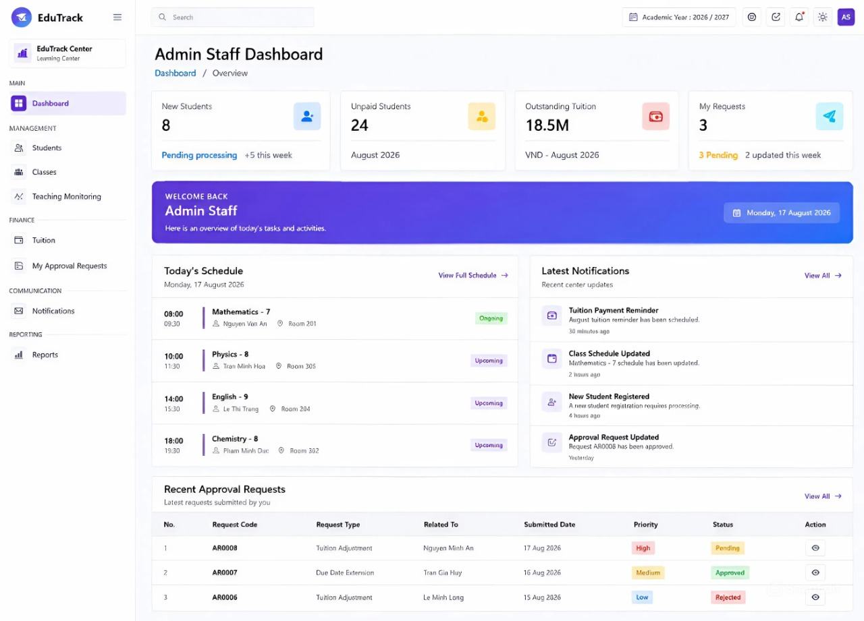
Figure 9. UI Prototype of Admin Staff Dashboard
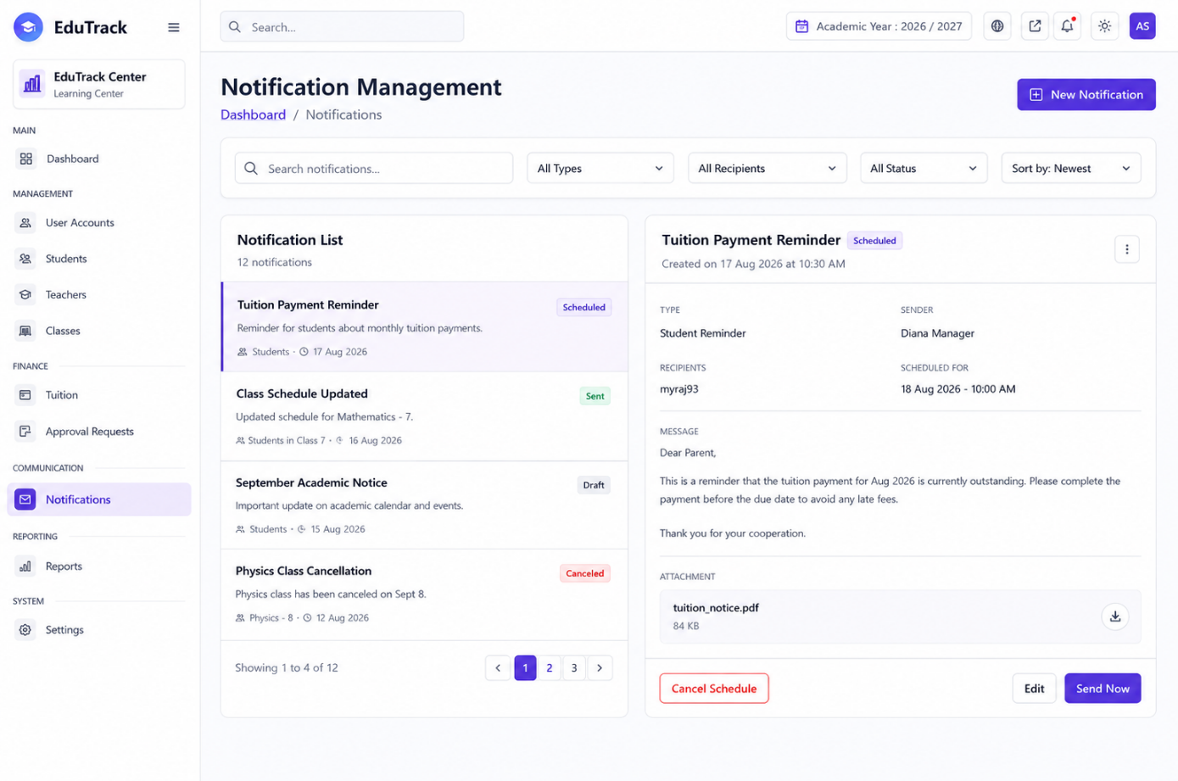
Figure 10. UI Prototype of Center Manager Notification Management

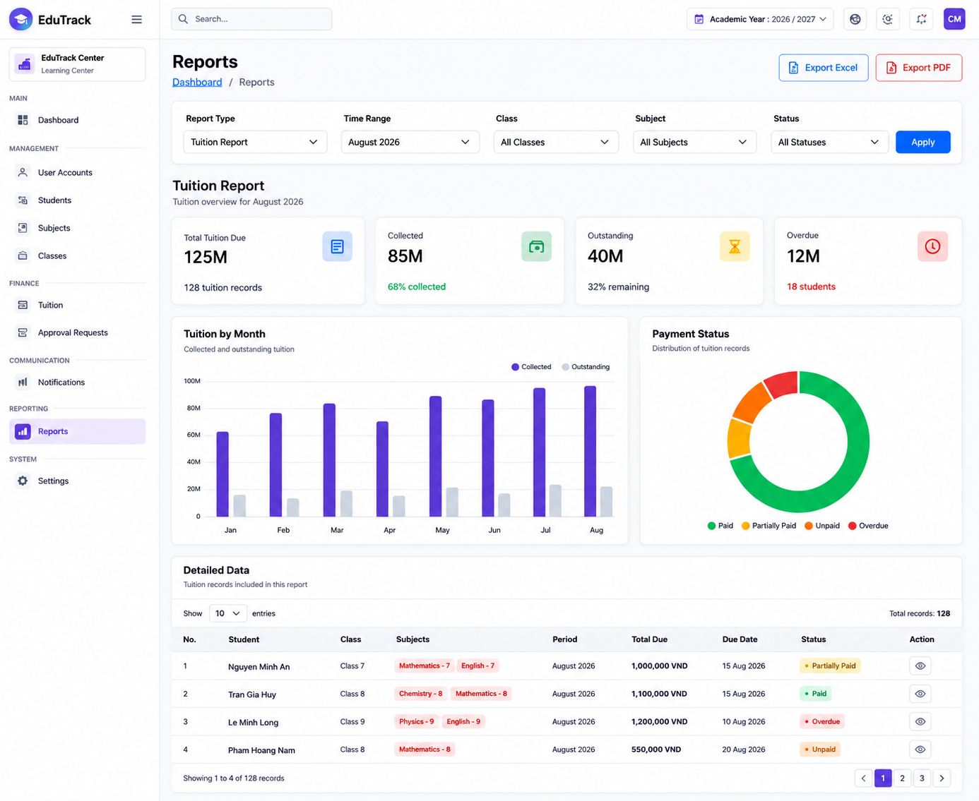
Figure 11. UI Prototype of Tuition Report

Teacher and TA UIs
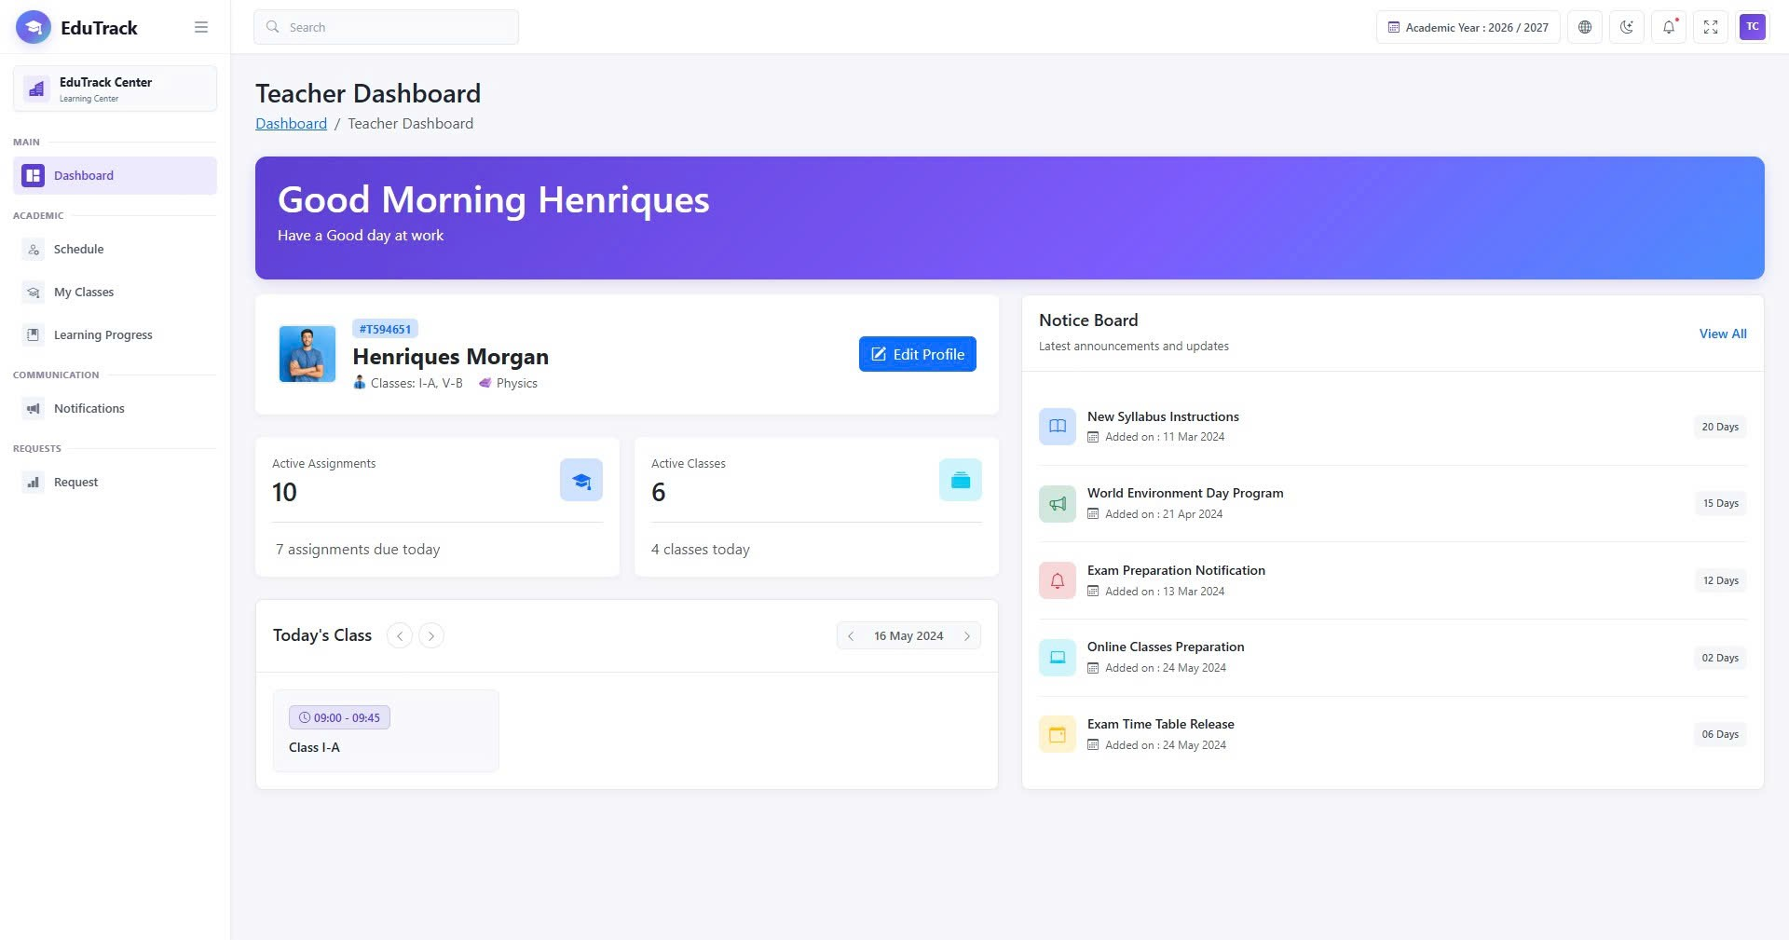
Figure 12. Teacher Dashboard Prototype

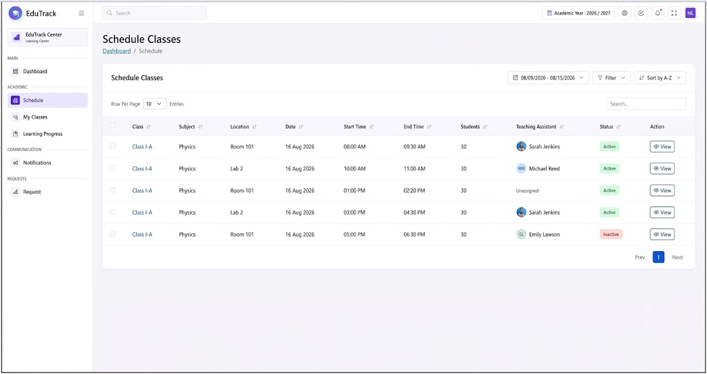
Figure 13. Class Schedule Interface Prototype

Student UIs
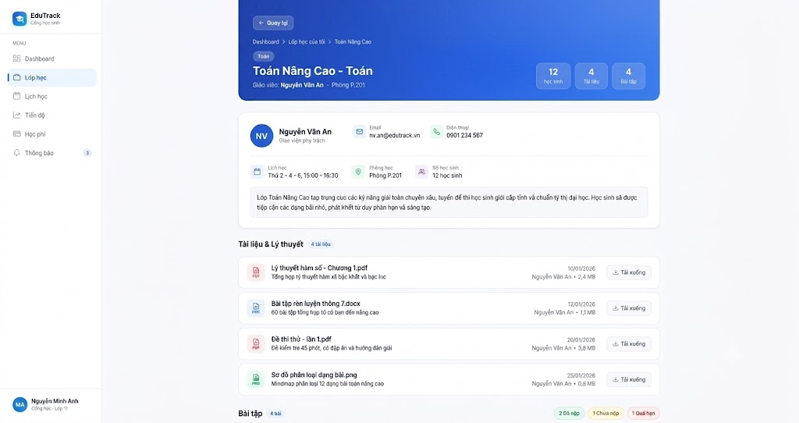
Figure 15. Class Detail interface for Students

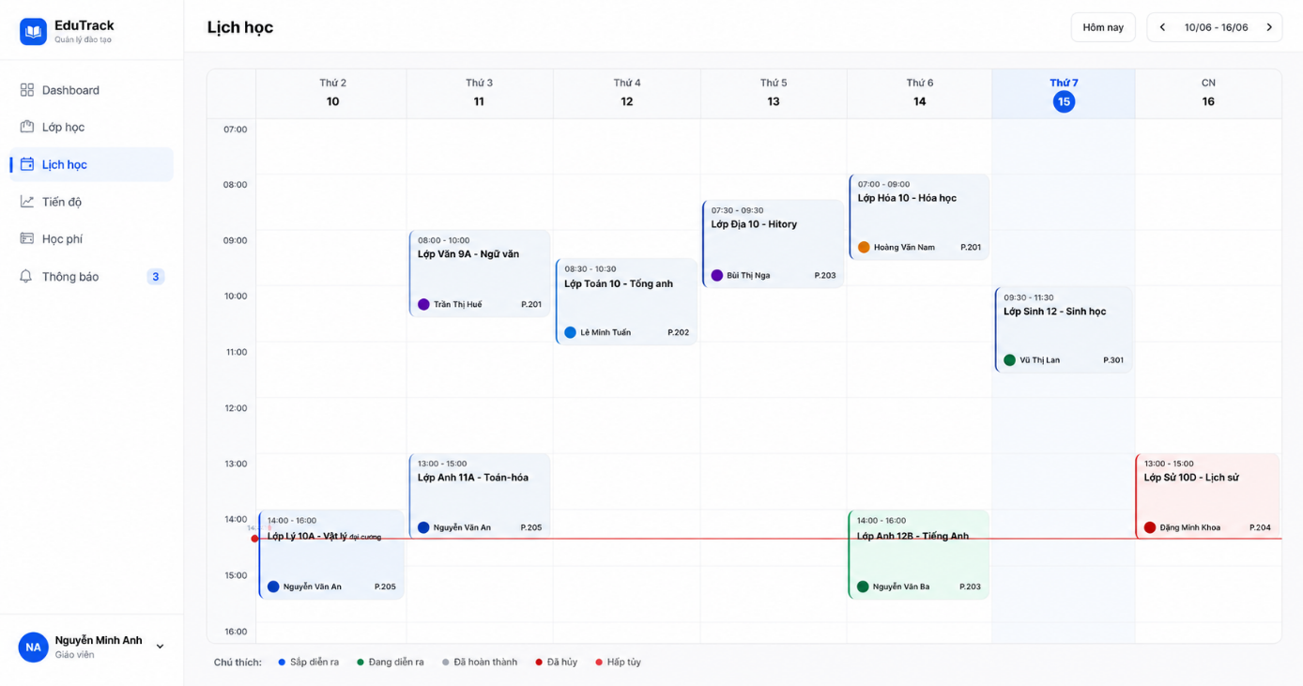
Figure 16. Interactive weekly schedule interface.

CONCLUSION & FUTURE WORKS

Conclusion
Throughout the development of Capstone Project I, our team has achieved significant progress and learned valuable lessons across multiple areas:
- Knowledge and Tools: We gained a clear understanding of foundational software engineering processes, from gathering requirements to designing system architectures. We also learned how to use essential practical tools such as Git for version control, and MySQL Workbench for database design.
- Product Value: We successfully analyzed the theoretical foundation for EduTrack. Although the project is currently in the analysis phase, the proposed system clearly outlines how it will help educational centers manage students, classes, and tuitions efficiently, replacing slow and error-prone manual paperwork.
- Technical Skills: We significantly improved our problem-solving and analytical skills. We learned how to translate real-world user needs into technical diagrams (such as Use Case and Activity diagrams) and how to build a logical, well-structured relational database (ERD).
- Soft Skills: Working closely together as a three-member team, we developed our communication and collaboration skills. We learned how to divide tasks effectively, resolve technical disagreements, and manage our time to meet project deadlines.

Future Works
Since Capstone Project I primarily focuses on system analysis, database design, and UI prototyping, the next phase in Capstone Project II will be dedicated to the technical implementation of the EduTrack system. Specifically, the future development plan will encompass the full-stack realization—from Front-end interfaces to Back-end logic—of all the functional features and business workflows analyzed in this report.

REFERENCES
- UNESCO, “Regulating private tutoring for the public good,” UNESCO, Dec. 09, 2021. [Online]. Available: https://www.unesco.org/en/articles/regulating-private-tutoring-public-good. [Accessed: Aug. 2026].
- Báo Chính Phủ, “Chuyển đổi số trường học với giải pháp hồ sơ số giáo dục và học bạ điện tử,” Báo điện tử Chính phủ, Sep. 13, 2022. [Online]. Available: https://baochinhphu.vn/chuyen-doi-so-truong-hoc-voi-giai-phap-ho-so-so-giao-duc-va-hoc-ba-dien-tu-102230913153327932.htm. [Accessed: Aug. 2026].
- TutorBird, “TutorBird: Tutor & Music Teacher Management Software,” TutorBird. [Online]. Available: https://www.tutorbird.com/. [Accessed: Aug. 2026].
- Easy Edu, “Phần mềm quản lý trung tâm giáo dục, đào tạo Easy Edu,” Easy Edu. [Online]. Available: https://easyedu.vn/. [Accessed: Aug. 18, 2026].
- EduSpace, “Phần mềm quản lý trung tâm đào tạo, ngoại ngữ toàn diện EduSpace,” EduSpace. [Online]. Available: https://eduspace.vn/. [Accessed: Aug. 2026].
- Moodle HQ, “Moodle: Open-source learning platform,” Moodle. [Online]. Available: https://moodle.org/. [Accessed: Aug. 2026].
- Meta Open Source, “React – The library for web and native user interfaces,” React.dev, 2024. [Online]. Available: https://react.dev/. [Accessed: Aug. 2026].
- Microsoft, “TypeScript: JavaScript With Syntax For Types,” TypeScriptlang.org, 2024. [Online]. Available: https://www.typescriptlang.org/. [Accessed: Aug. 2026].
- Microsoft, “ASP.NET Core Documentation,” Microsoft Learn, 2024. [Online]. Available: https://learn.microsoft.com/en-us/aspnet/core/. [Accessed: Aug. 2026].
- Oracle Corporation, “MySQL Documentation,” MySQL.com, 2024. [Online]. Available: https://dev.mysql.com/doc/. [Accessed: Aug. 2026].
- Auth0, “JSON Web Tokens,” JWT.io. [Online]. Available: https://jwt.io/. [Accessed: Aug. 2026].

